Govt. High School
Sindhi Jamaat Co-Operative Housing Society, Karachi
Parent Teacher Meeting
Class: ECE
Date: 25-1-2025
Time: 9:00 AM to 12:00 PM

Report:
- 3rd PTM was Conducted on 25 January 2025 for ECE Classes. (Delay the date 4th January due to Strength of Students).
- These are the following points we are discuss.
- Progress of Students.
- Syllabus and Time table (Final Term).
- Home Work.
- Attendance.
- Curriculum.
- Healthy Food.
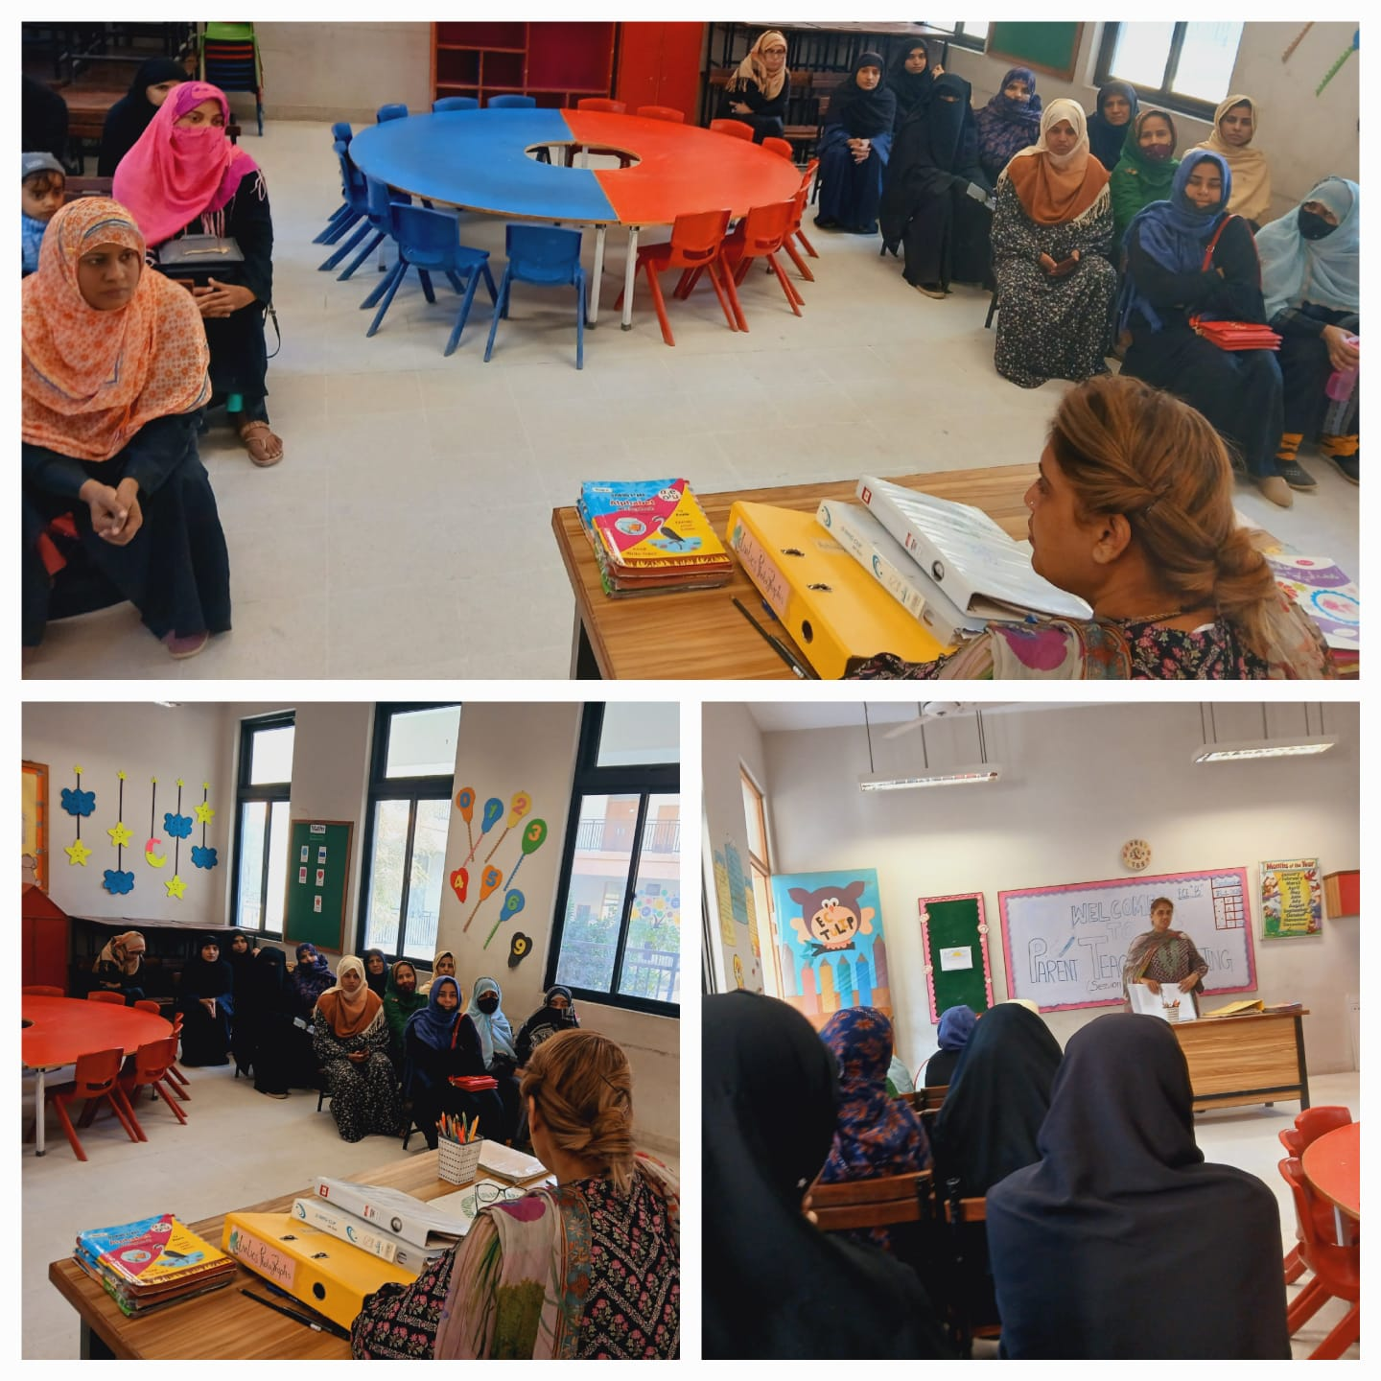
- Cleanness.

